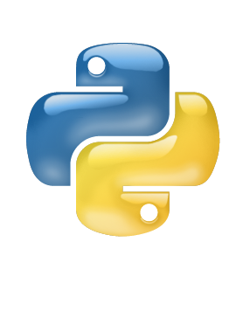

Python

MOdule

Lab

Tutorial

Class X

Lab 14

1. Try to complete the stage from 11 to 20 of Code Commander